Updating Stock Tariff codes for a specific customer,

1) Search for the customer
2) Select Stock References
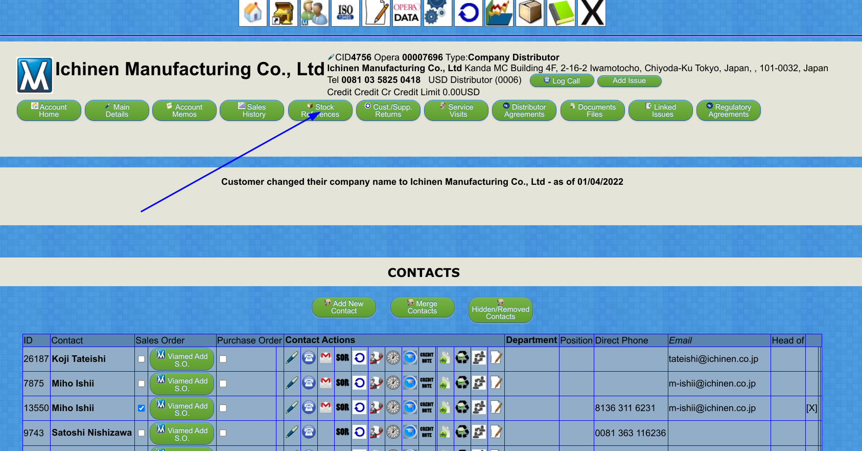
3) Click Customer References for Sales Orders

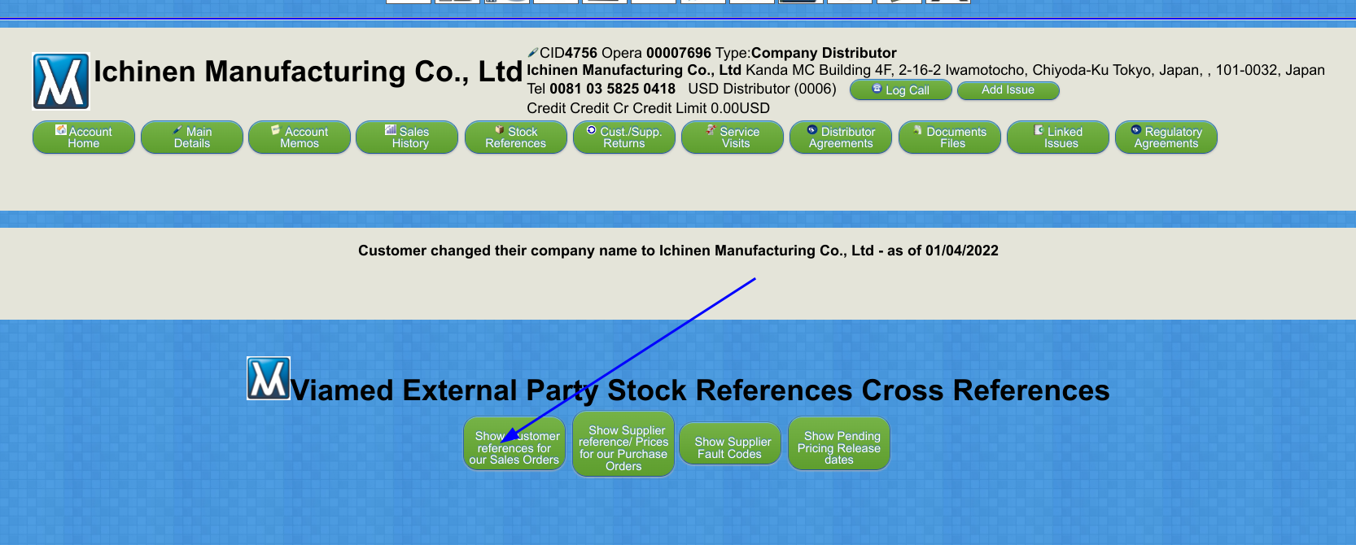

4) In the Add Single Item box enter the Part number to have unique Tariff codes

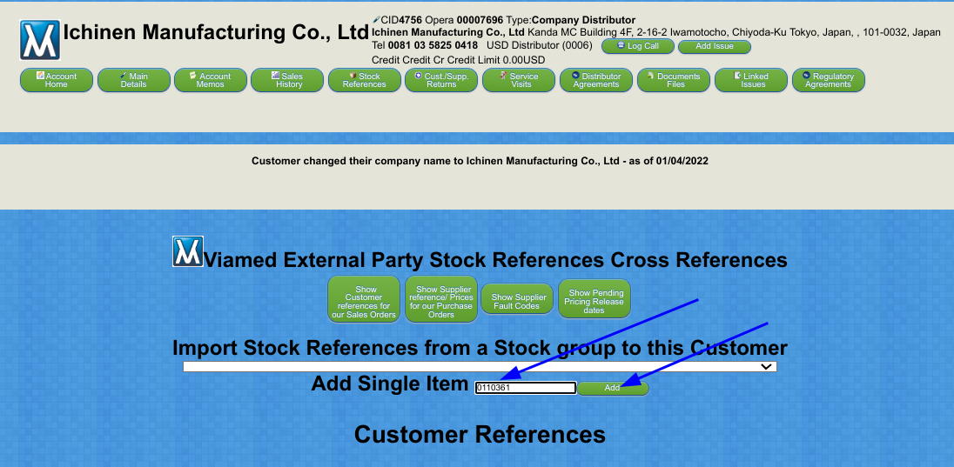
5) In the the Part number should Appear,
Fill in the Customer Part Number – usually the same as ours,
Fill in the Customer Description – usually the same as ours,
Fill in the required Tariff Code
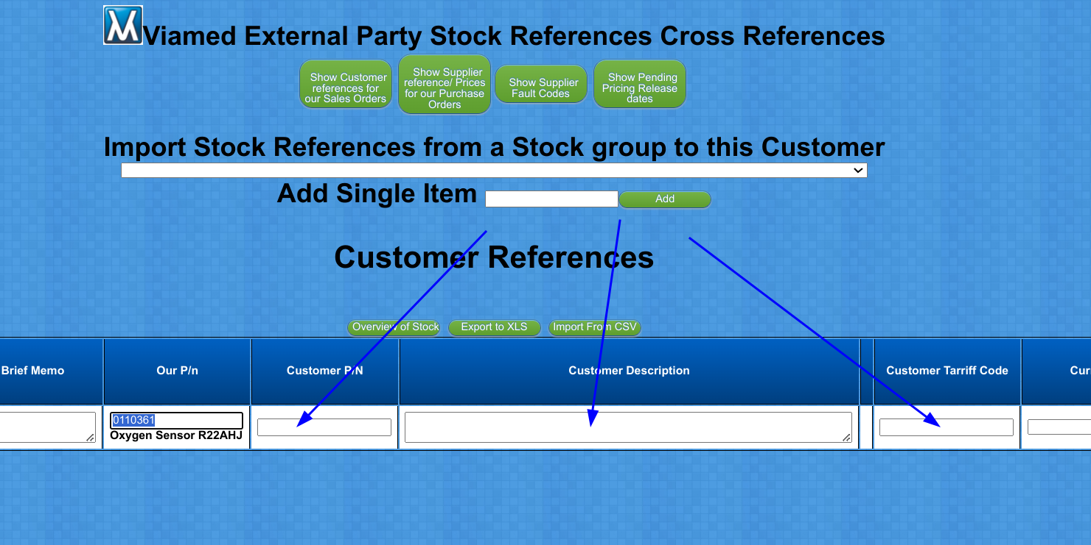

6) Click the Update Button



