VM3COP53.07 Ceratherm 600-2 Labels Print Procedure
Please Note: This can only be completed on a PC with Adobe InDesign Installed – Currently on Catrin’s.
Labels can be found on the shelves in Catrin’s office, Ghyll House.

- Open Nextcloud\NextCloud\T Drive\Artwork\Labels\Ceretherm 600-2 Labels\Ceretherm 600-2 labels 65x48.indd file in Adobe InDesign.
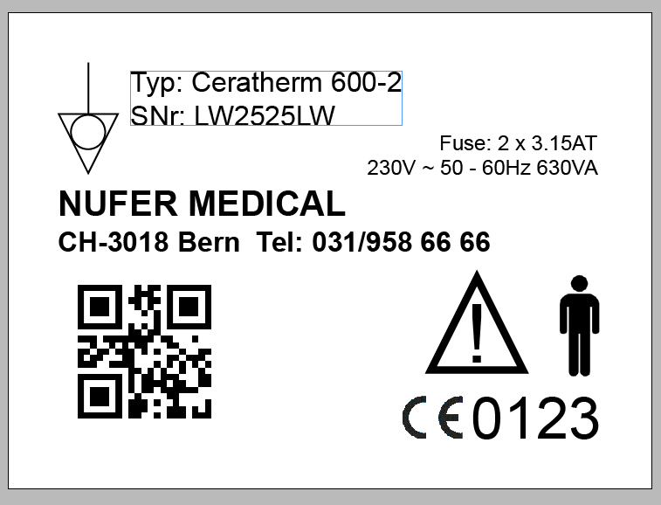
Serial Number
QR Code

- Click into the text box showing the Serial Number. Edit the serial number to the one provided by the customer.
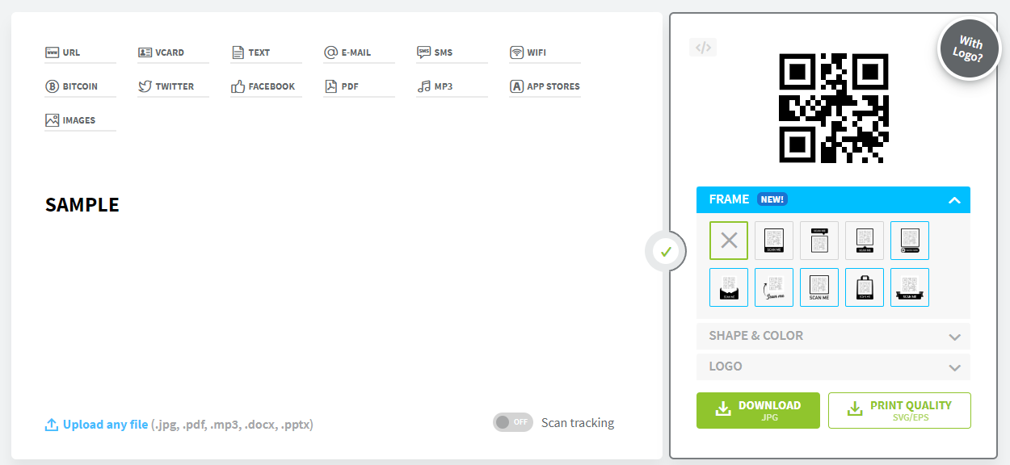
- Go to www.qr-code-generator.com and insert the serial number into the white box. This will generate the required QR code.
- Click the green download button and wait for the QR code to download.
Depending on your browser it may ask you to provide a download name or it might automatically download to your Downloads folder.
- Go back to the InDesign file and click black arrow icon in the top left hand corner of the screen.
- Click the QR code which is already placed in the file.

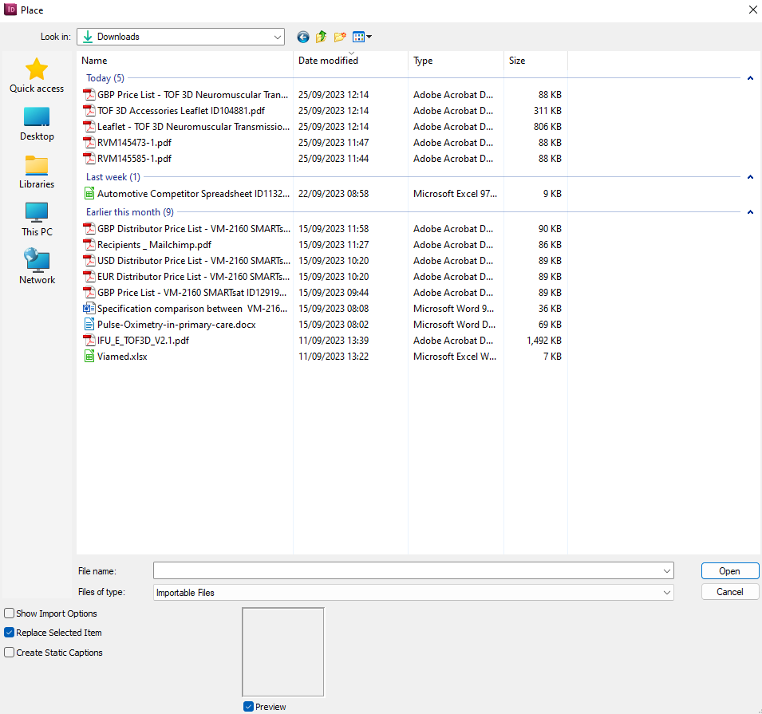
- Press Ctrl + D on the keyboard, this will open Place, File Explorer window.
Navigate to the file you have just downloaded. If it has gone to Downloads, click This PC then Downloads.
- Click the file relevant QR code file and click open. This will place the QR code into the document.
- Your label is now generated.
Press Ctrl + E, to export the file.
Save this as a PDF to the Downloads folder, for ease.
- Go back to File Explorer and open Nextcloud\NextCloud\T Drive\Artwork\Labels\Ceretherm 600-2 Labels\Ceretherm Labels Print.indd

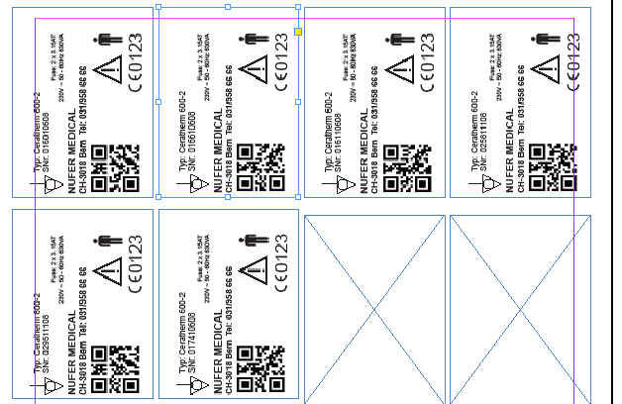
- Looking at the label sheets you are going to use, click the relevant box where you would like the label to print and press Ctrl + D.
- Navigate to the saved label file, click it and click open.
This will place the image into the document.
Delete anything you do not wish to print.
- Export the file (Ctrl + E) as a PDF.
This will open the PDF file for you to print the labels onto.

Print Settings
Please make sure that the settings set to print “Labels”.
(The procedure is to be updated once access to printer is available).

