1.
Measure 5cm from the Left edge at the back of the cabinate door.
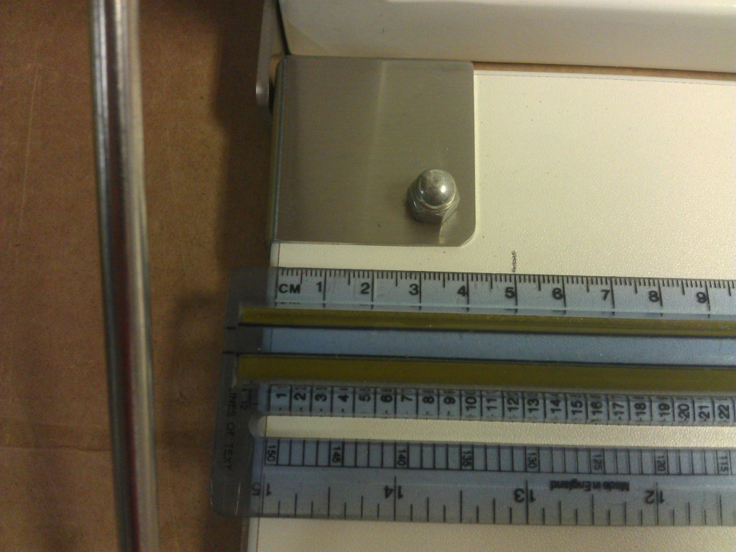
2.
Measure 5cm from left edge towards the front of the door.
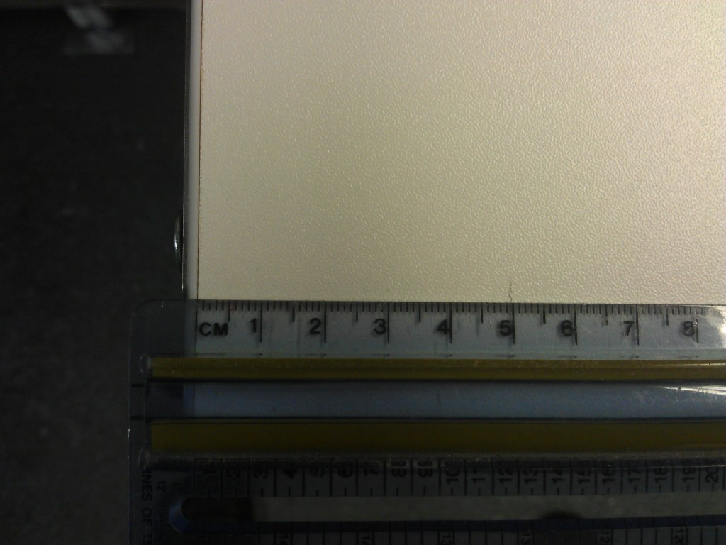

3.
Line the replacement bed up with 5cm marks, and align the front lipped edge in line with the edge of the door.
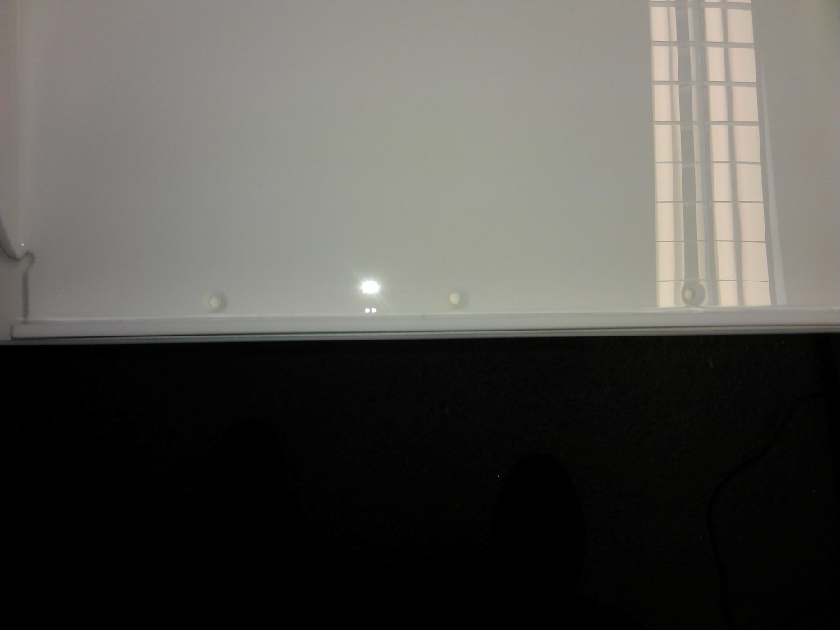
4.
Using a drill with a Xxmm size drill bit, create a starting hole ? , fix the bed into place.



