Xero linking of the bank to Barclays, Barclaycard or PayPal

On Xero it will tell you in red, on the dashboard if a bank, credit card or PayPal account needs linking or refreshing.

Usually this is done by just clicking refresh and it will then process this without further details.

Sometimes it will require you to log in to the Barclays bank or the Barclaycard or PayPal system. Xero will take you to the website and you will need to login.

To be able to link Barclays or refresh you have to have to have the company bank accounts linked to your private Barclays account. Xero will let you select Business accounts and click the correct companies bank.

You need to be a signatory on the account and then the accounts can show on your private Barclays App.

Barclays telephone staff are very good, if you need adding to the Bank you ring them and tell them, they should be able to talk you through it.

Helen, Derek and Jean are all signatory not all have all the accounts on their apps. But they should be able to if needed.

Xero looks like this
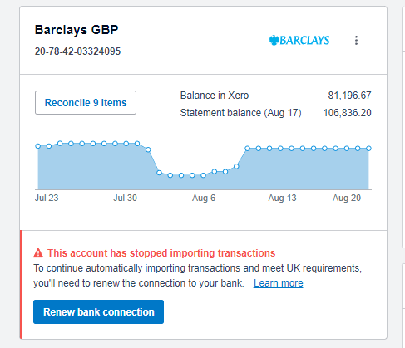
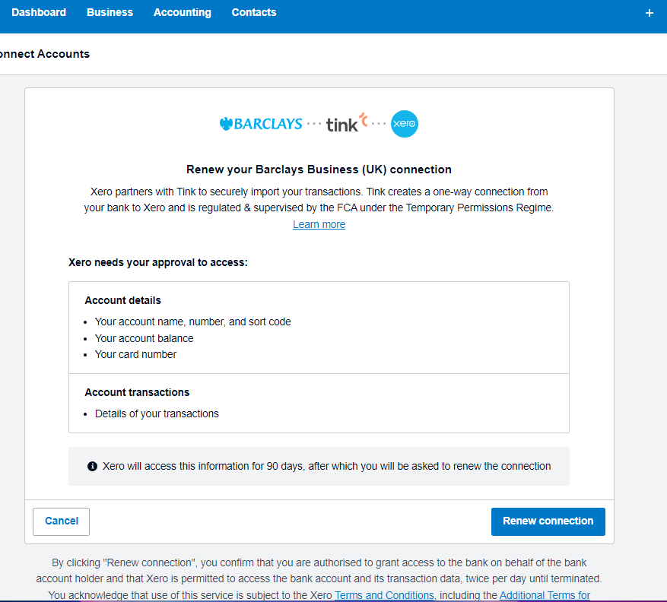
Then this

