Nufer Ceratherm Technical Training

What is a radiant warmer and why are they used?

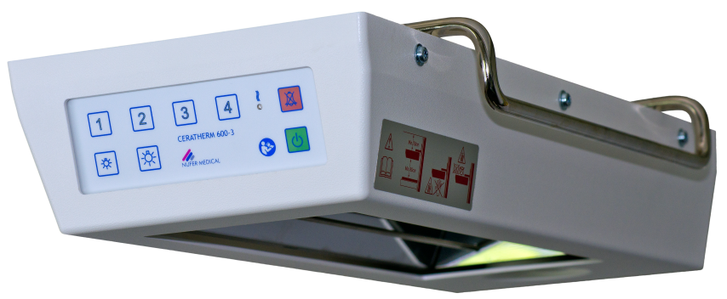
Ceratherm 600-3

A radiant warmer is a device used to deliver gentle heat in a clinical application.

Heat has a tendency to flow in the heat gradient direction, i.e. from high temperature to low temperature.

Ceratherm radiant warmers can be used on adult, paediatric and neonatal patients, with neonatal being the most common.

Neonates have low body mass, so they can lose heat rapidly. Radiant warmers help to keep the body temperature constant in the time immediately after delivery.

Ceratherm radiant warmers provide a curtain of warmth to prevent heat loss.
Mounting options

Ceratherm radiant warmers can be wall mounted, ceiling mounted or free standing.

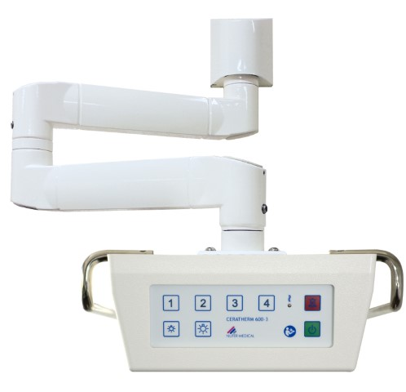
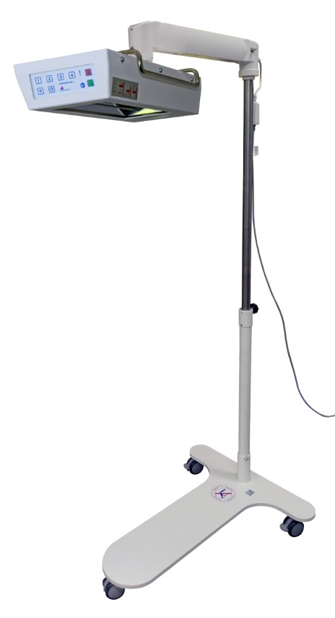
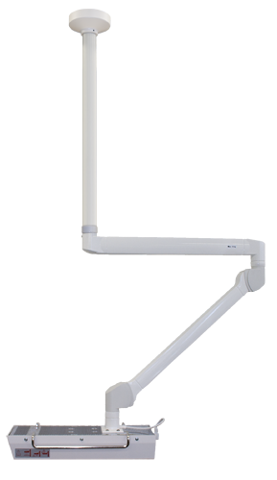

The most commonly supplied type is the wall mounted radiant warmer with double hinged arm (p/n 0310302), it is not height adjustable and requires a minimum clearance distance of 80 cm from the underside of the warmer head unit to the patient surface.

The radiant warmer on mobile floor stand (p/n 0310304) is height adjustable and also requires a minimum clearance of 80 cm.
How do radiant warmers generate heat?

Ceratherm radiant warmers utilise a 600W ceramic heating element, housed in front of a metal reflector to spread the heat evenly.

The underside also features an LED lamp for illumination of the patient surface.

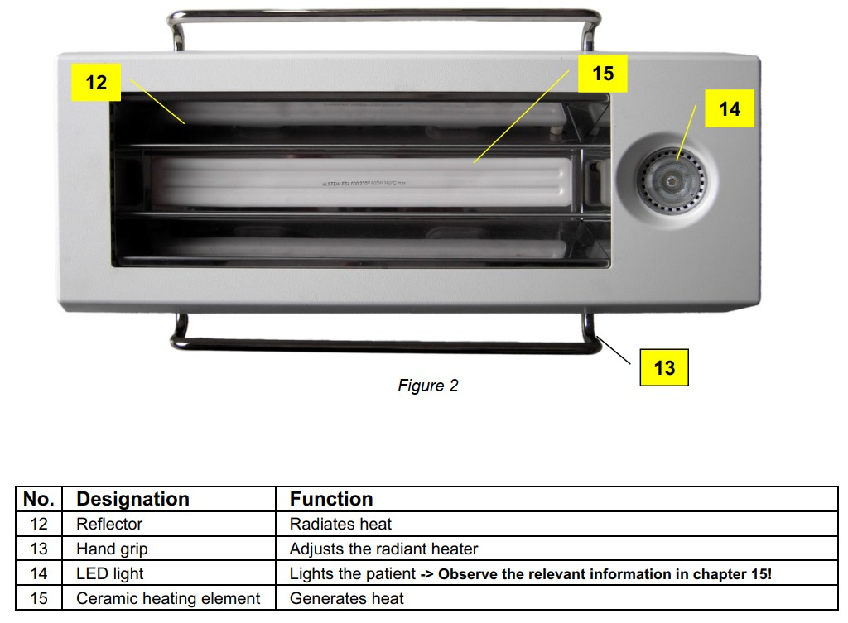
Description of parts from Instructions For Use
The heating element generates invisible infrared radiation at a wavelength of around 3 µm. This part of the radiation spectrum is absorbed very effectively by the skin and causes no harm to the patient’s eyes.

Controlling the temperature

Radiant Warmers can be manual or automatic using a servo system in which heat output is determined automatically based on skin temperature, they use skin temperature probes to feed information back to the radiant warmer.

All Ceratherm radiant warmers are manual control: heat output is adjusted using power settings, levels 1 to 4, which are set by pressing the corresponding button on the control panel, which illuminate to show the current setting.
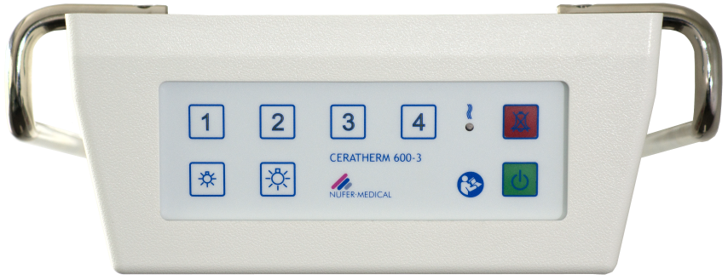

The following standard values are set by default:

Level 1 = 20% Level 2 = 50 % Level 3 = 75 % Level 4 = 98 %

 | WARNING!  The radiant warmer must not be left unattended whilst in use.

Alarm and safety-power function

The radiant warmer incorporates a safety feature, which reduces the output power if the device is left unattended. An audible and visual alarm is triggered 15 minutes after the last key-press; this is to inform the operator that the device is still active.

If after 8 seconds from the onset of the alarm condition the alarm has not been cancelled, the heat output of the radiant warmer reduces to a power level of 20% and will remain at this level until the red illuminated alarm button is pressed.

When the alarm is reset, the device powers back up to it’s previous heat setting and the 15-minute cycle repeats.

LED heating indicator

The Heating Indicator illuminates when the element is being heated, and is off when it is not.

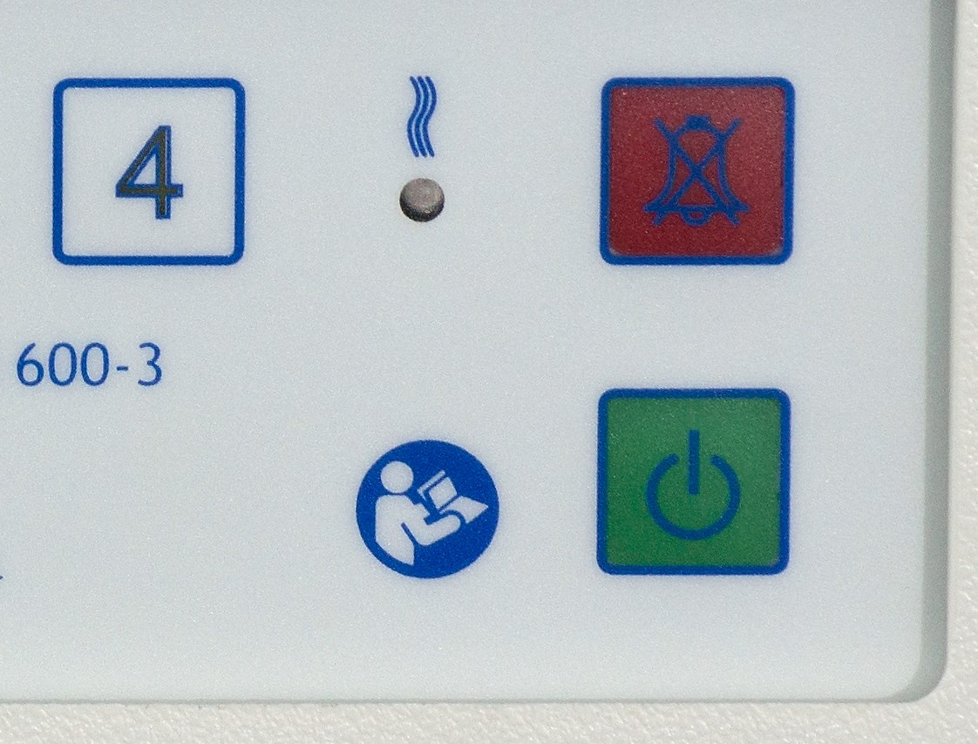
This ‘duty-cycle’ occurs over a period of 2 seconds, the percentage of time that the indicator is illuminated during that cycle represents the power level in terms of a percentage of the maximum output.

Example: if a 50% output has been selected, for example, the LED lights up for roughly 1 second and is out for roughly 1 second.
LED lamp

The Ceratherm 600-3 has a LED lamp with 2 brightness settings, activated using the buttons on the control panel.
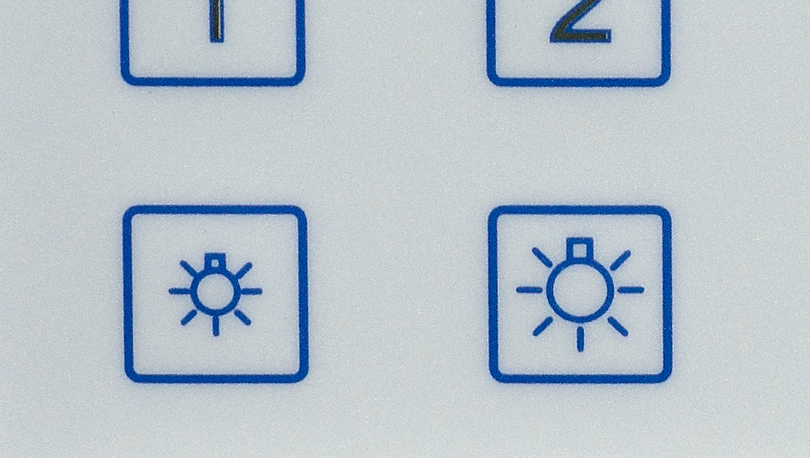

The low setting is 20% of full brightness, the high setting is 100%

Mains failure detection

The Ceratherm 600-3 has an internal capacitor that allows the control system to remain active and sustain an audible alarm for a period of 10 – 15 minutes.

If the power returns whilst the control panel is still active, the device will return to normal operation at the previous heat setting.

If the capacitor becomes drained due to a longer power outage, the device will enter standby mode; to reactivate it, it must be switched on again and the power level must be selected.

Infant Resuscitation Cabinet

Most of the Ceratherm radiant warmers that Viamed has supplied included with the wall mounted Infant Resuscitation Cabinet, which is now discontinued.

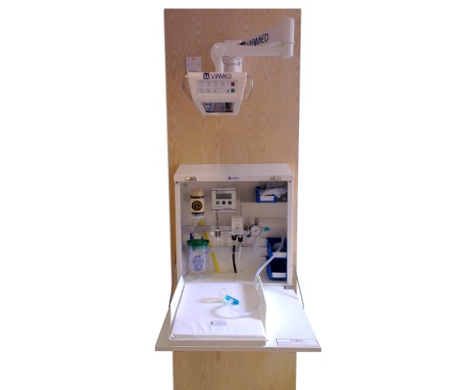
Infant Resuscitation cabinet installed in a Delivery Suite

Warranty

The customer warranty is 12 months from the date of invoice on all Ceratherm radiant warmers.

Maintenance/Service

Viamed no longer offers on-site servicing at customer premises for radiant warmers or the Viamed Infant Resuscitation Cabinet.

Spare parts are available, please be sure to ask the customer for the exact model to ensure compatibility. A service manual can be provided to assist with repairs.

Radiant warmers can be returned to Viamed for service, but this is discouraged due to the potential for damage to the ceramic element, which is brittle.

For devices returned to Viamed, repairs are carried out using the standard labour rate plus the cost of replacement parts.

Latex

All devices are latex-free.

Where to find additional information

- Viamed website
- Nufer website
- Product leaflets – linked to stock pages
- FAQs on the stock page
- Memos on the stock page
- Instructions for use

