Specification
Range | 0- 100% Oxygen
Accuracy : | +/- 1% of full scale
Response Time | 90% step change < 10sec
Resolution : | +/- 0.1 %
Battery Type : | MN1500 LR6 1.5v
Battery Life : | 12 months (typical)
Sensor Type : | R-17VAN (Galvanic)
Sensor Life in air | Expected 36-48 months (10 months in 100%O2)
Sensor output | 7.5mV - 13.5 mV in air
Dimensions | 60mm x 120mm x 35mm
Weight | 198 gms including battery & sensor
Storage Temp | 0º-50º C (recommended 10-30C)
Operating Temp | 0º-40 ºC
Case : | Splash proof
Waterproofing | IP65 NEMA 4
ISO Standards | ISO EN 9001:2000
EMC CE | ISO EN 60601-1-2
RoHs | Complies with RoHS
WEEE | Complies with WEEE
Specification subject to change
Accessory Parts list
 |  | R-17VAN Micro Fuel Cell
 |  | DINKIT Restricter Kit
 |  | A-268 Tee Adaptor
 |  | B-50057 Flow- Divertor
 |  | DM22M10 Male adapter
 |  | BS111 Viton O Ring
 |  | DIN22F Restrictor,
 |  | Quick-Ox gas sampling kit
 |  | V mount clamp
 |  | V mount adapter
 |  | Lanyard
 |  | Waterproof box
9530002 |  | Battery/Sensor cover seal
9520001 |  | TEK-OX sensor extension
 | Trouble shooting
 | Symptom |  | Possible Cause
 | No Display |  | Not switched on Battery exhausted  Batteries in wrong way
 | Batt Lo symbol |  | Replace low battery
 | Zero Reading |  | Sensor exhausted Sensor disconnected Rotate sensor whilst in the instrument. There may be a deposit on the Jack plug or the sensor Jack socket
 | Not calibrating |  | Sensor nearly exhausted Check sensor in 100% then Check sensor again in Air
 | Reading drifts |  | Sensor nearly exhausted; in flowing gas Temperature changing wind blowing on divertor
 | Inaccurate reading |  | Move away from RF source, Boat VHF radio Do not use flowing gas use On/Off /On/Off system:Condensation on sensor face Remove condensate by shaking


Vandagraph Ltd 15, Station Road, Crosshills,
Keighley West Yorkshire, BD20 7DT. United Kingdom.
Tel 01535 635900
Fax 01535 635582
www.vandagraph.co.uk
sales@vandagraph.co.uk
technical@vandagraph.co.uk

VN202 mkII
Oxygen Analyser
User Manual

These instructions should be read before
using the

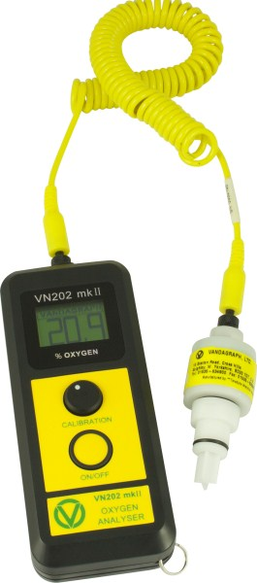

Mixed gas diving should only be undertaken by divers trained by a recognised training organisation.
Copyright 2007 Vandagraph Ltd.
. All worldwide rights reserved.
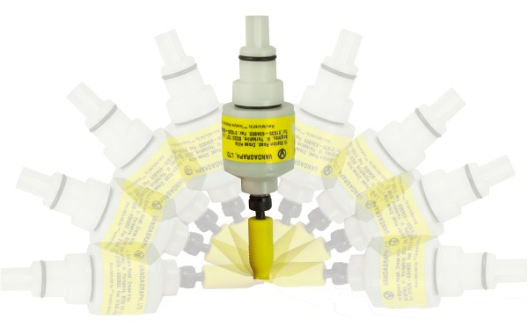
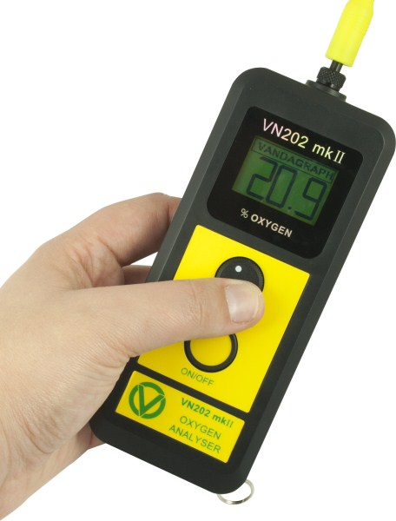
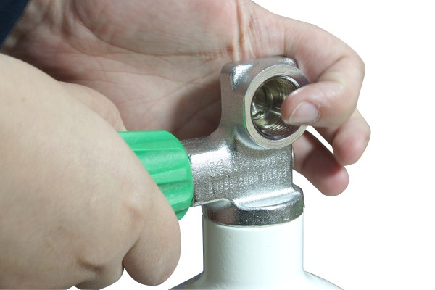
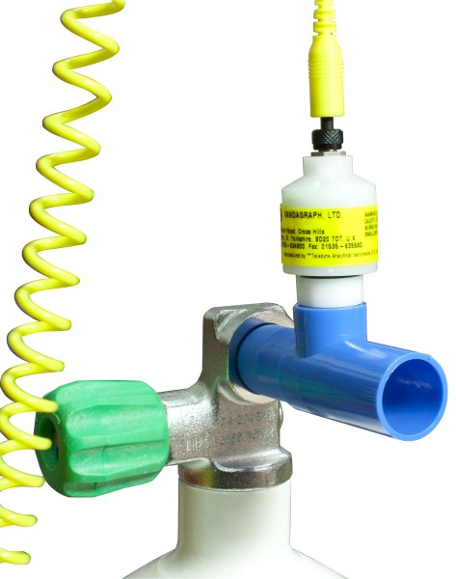
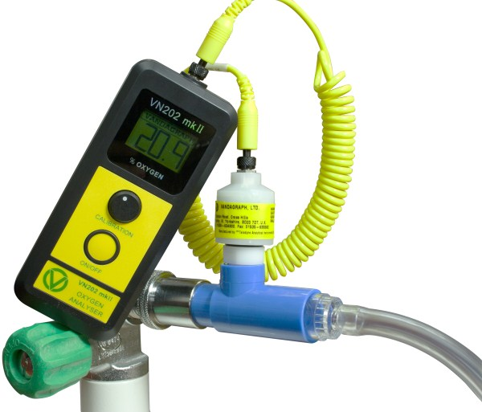
Contents
Please check you have the following items:
1 VN202
2. Quick-Ox or DINKIT
The Vn202mkII
has been designed as one of the next generation of diving Oxygen analysers following onfrom the sucessful VN202 Suitable for the worldwide hostile diving environment it is easy to use with either hand,:and has very large digits.
It uses the proven R-17VAN oxygen sensor (as used in the VN202) with integral temperature compensation
It is powered by two internationally available AA alkaline batteries with an estimated life of 12-18 months. The instrument is available in two versions:
Yellow On/Off button automatic switch off.
Green On/Off button non automatic switch off The instrument is sealed for water resistance (IP65) and designed to be drop resistant. The battery is housed in a separate compartment from the sealed electronics and can be changed without the use of a tool. Ensure batteries are fitted correctly. See internal labels
Full comprehensive user manual is available as a download from

www.Vandagraph.co,uk/manual.
Just register your purchase.

How to use the VN202 mkII
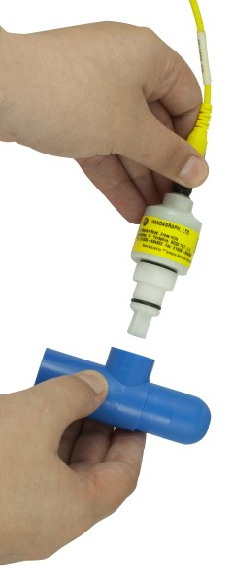
1.Leave Flow divertor on;
Wave through the Air

2. Adjust Calibration

3. Add The Quick-Ox

4,Turn on the Gas to a
gentle Flow

5.Mate the Quick-Ox
to the cylinder outlet

6.When the reading stops rising turn off cylinder
If in doubt repeat!

Effects of Altitude & Humidity
At very high altitudes some sensors (with high outputs) may not calibrate down to the level required. In this instance total pressure, ambient and altitude must be taken into consideration
Feet | Metres | Pressure mb | Cal
-1000 | -305 | 1.03 | 21.5
0 | 0 | 1 | 20.9
1000 | 305 | 0.97 | 20.2
2000 | 610 | 0.94 | 19.4
3000 | 915 | 0.92 | 18.7
4000 | 1220 | 0,89 | 18.1
5000 | 1220 | 0.89 | 17.4
6000 | 1830 | 0.84 | 16.8
8000 | 2440 | 0.79 | 15.5
10,000 | 3050 | 0.74 | 14.4
12,000 | 3660 | 0.69 | 13.3
Although not substantial, humidity can effect the maximum accuracy that can be obtained. This accounts for the difference observed between ambient air calibration and calibration with dry gas from a cylinder
 | RH40% | RH60% | RH80% | RH100%
0ºC/32ºF | 20.9% | 20.8% | 20.8% | 20.8%
10ºC/50ºF | 20.8% | 20.7% | 20.7% | 20.6%
20ºC/70ºF | 20.7% | 20.6% | 20.5% | 20.4%
30ºC/90ºF | 20.5% | 20.3% | 20.1% | 19.9%
40ºC/100ºF | 20.4% | 20.1% | 19.8% | 19.5%

Using the VN202 mkII with a DINKIT
Follow instructions 1-6 as with Quick-Ox. See information on DINKIT

